ThesisCode

## Facebook Data Extraction

library(Rfacebook)  
  
# Fb Authorization  
fb_oauth <- Rfacebook::fbOAuth(  
 app_id="1380496555352781",  
 app_secret="eb3abc42d1e00536e6f4e37e58fc0b5d",  
 extended_permissions = TRUE)  
  
# Saving variable fb_oauth in a file and loading it  
save(fb_oauth, file="fb_oauth")  
load("fb_oauth")  
  
# Extract posts from turkish airlines page  
turkishairlines <- Rfacebook::getPage(page = "turkishairlines",   
 token = fb_oauth, n = 2000)  
  
# Save the posts in R data file  
saveRDS(turkishairlines, "turkishairlines_2000")

library(dplyr)

##   
## Attaching package: 'dplyr'

## The following objects are masked from 'package:stats':  
##   
## filter, lag

## The following objects are masked from 'package:base':  
##   
## intersect, setdiff, setequal, union

# Read R data file and store in new variable  
data_turkishairlines <- readRDS("turkishairlines_2000")  
  
# Storing the post ids in a new variable  
data_turkishairlines_id <- data_turkishairlines$id  
  
# Viewing limited variables and rows  
data_turkishairlines %>%   
 dplyr::select(from_id, likes_count, type, comments_count,   
 shares_count, message) %>%   
 tibble::as_tibble() %>%   
 head(5)

## # A tibble: 5 x 6  
## from_id likes_count type comments_count shares_count message   
## <chr> <dbl> <chr> <dbl> <dbl> <chr>   
## 1 90430042759 254 photo 12 18 Our flights t…  
## 2 90430042759 300 photo 132 92 "We are looki…  
## 3 90430042759 869 photo 39 43 The most plea…  
## 4 90430042759 261 photo 9 7 Famous actor …  
## 5 90430042759 227 photo 13 11 Within the sc…

data_turkishairlines %>%   
 dplyr::select(message) %>%   
 tibble::as_tibble() %>%   
 head(2)

## # A tibble: 2 x 1  
## message   
## <chr>   
## 1 Our flights to Samarkand start on March 16th, 2018!   
## 2 "We are looking for new pilots! Join us at Turkish Airlines Pilot Roads…

# Extracting comments and reactions from the extracted posts  
# The comments are extracted using post ids. Therefore, id variable  
# is used.   
all_posts <- data_turkishairlines_id[1:300] %>%   
 lapply(getPost, n = 50000, token=fb_oauth,   
 comments = TRUE, reactions = TRUE)  
  
# Save first 300 posts comments in a R data file.  
saveRDS(all_posts, "300_posts")

# Converting Facebook lists data into dataframe

# Reading the saved RDS file instead of applying getPost function repeatedly.  
# The resultant variable is a list which includes a post specific list.  
# Within each post specific list there are post comments and reactions.  
threehundred_posts <- readRDS("300_posts")   
  
# Saving comments for first post in new variable  
full_comments <- threehundred_posts[[1]]$comments$message %>%  
 as.data.frame() %>%   
 setNames("comments") %>%  
 dplyr::mutate(id = data_turkishairlines_id[1])  
  
# Expanding full_comments by adding comments of remaining posts.   
for (i in 1:299) {  
 comment <- threehundred_posts[[i+1]]$comments$message %>%   
 as.data.frame() %>%   
 setNames("comments") %>%  
 dplyr::mutate(id = data_turkishairlines_id[i+1])  
 full_comments = rbind(full_comments, comment)  
}  
  
# Assigning the post ids to its comments.   
# The posts ids are repeated when there are more than one comment.   
full_comment_post <- full_comments %>%   
 dplyr::left_join(data_turkishairlines, by = "id")  
  
# Saving the comments of posts in R data file.   
saveRDS(full_comment_post, "300_posts_comments")

readRDS("300_posts_comments") %>%   
 subset(select = c(3,1,2,4,5,6,7,8,9,10,11)) %>%   
 tibble::as_tibble() %>%   
 head(5)

## # A tibble: 5 x 11  
## from_id comments id from_name message created_time type link story  
## <chr> <fct> <chr> <chr> <chr> <chr> <chr> <chr> <chr>  
## 1 9043004… Direct … 9043… Turkish … Our fl… 2017-10-05T… photo http… <NA>   
## 2 9043004… Just cu… 9043… Turkish … Our fl… 2017-10-05T… photo http… <NA>   
## 3 9043004… What ab… 9043… Turkish … Our fl… 2017-10-05T… photo http… <NA>   
## 4 9043004… What ab… 9043… Turkish … Our fl… 2017-10-05T… photo http… <NA>   
## 5 9043004… Very in… 9043… Turkish … Our fl… 2017-10-05T… photo http… <NA>   
## # ... with 2 more variables: likes_count <dbl>, comments_count <dbl>

readRDS("300_posts_comments") %>%   
 dplyr::select(comments) %>%   
 tibble::as_tibble() %>%   
 head(2)

## # A tibble: 2 x 1  
## comments   
## <fct>   
## 1 Direct flight from Ireland to bodrum badly needed even twice a week in …  
## 2 Just curious you do flights to Tbilisi?

## Twitter Data Extraction

# Load Requried Packages  
library("SnowballC")  
library("tm")  
library("twitteR")  
library("syuzhet")  
  
# Authonitical keys  
consumer_key <- 'tAyR9LyhATfD90aA7Ft1Zfj3I'  
consumer_secret <- 'vX1RHqHHDpnmNOqrGPMVnmnQjQvG98X3xlB7T7zv4hKcvj7tVv'  
access_token <- '2572842085-vExbB4HNvN57zmQhoQdbmutC16a4kdMdh1xVta5'  
access_secret <- 'HtTHSeAOz1WPcUX8nfW5ddwZ1TbXZGFB4pSHU0IZ3agvA'  
  
twitteR::setup_twitter_oauth(consumer_key, consumer_secret,   
 access_token, access_secret)  
  
tweets <- userTimeline("turkishairlines", n=200)

## Trip Advisor Data Extraction

library("rvest")  
  
url <- "https://www.tripadvisor.com/Airline_Review-d8729174-Reviews-Turkish-Airlines"  
url <- "https://www.tripadvisor.com/Airline_Review-d8729174-Reviews-or20-Turkish-Airlines#REVIEWS"  
  
df_total = data.frame()  
  
for (i in seq(0, 20050, 10))  
{  
 if (i == 0) {  
 url <- "https://www.tripadvisor.com/Airline_Review-d8729069-Reviews-Emirates"  
 }  
   
 else {  
 url <- paste(  
 "https://www.tripadvisor.com/Airline_Review-d8729069-Reviews-or",i,"-Emirates#REVIEWS",   
 sep = "")  
 }  
   
 reviews <- url %>%  
 read_html() %>%  
 html_nodes("#REVIEWS .innerBubble")  
   
 id <- reviews %>%  
 html_node(".quote a") %>%  
 html_attr("id")  
   
 quote <- reviews %>%  
 html_node(".quote span") %>%  
 html_text()  
   
 rating <- reviews %>%  
 html_node(".rating .rating_s_fill") %>%  
 html_attr("alt") %>%  
 gsub(" of 5 stars", "", .) %>%  
 as.integer()  
   
 date <- reviews %>%  
 html_node(".rating .ratingDate") %>%  
 html_attr("title") %>%  
 strptime("%b %d, %Y") %>%  
 as.POSIXct()  
   
 review <- reviews %>%  
 html_node(".entry .partial_entry") %>%  
 html_text()  
   
 df <- data.frame(id, quote, rating, date, review, stringsAsFactors = FALSE)  
 df_total <- rbind(df_total, df)  
}  
  
# Save an object to a file  
saveRDS(df_total, file = "tripadvisor_turkishairlines6846.rds")

trip_turkishairlines <- readRDS(file = "tripadvisor_turkishairlines6846.rds")  
  
trip_turkishairlines %>%  
 dplyr::select(id, date, quote, rating, review) %>%   
 tibble::as_tibble() %>%   
 head(5)

## # A tibble: 5 x 5  
## id date quote rating review   
## <chr> <dttm> <chr> <int> <chr>   
## 1 rn575914601 2018-04-26 00:00:00 Never ag… NA "\nTo start with me an…  
## 2 rn575863809 2018-04-26 00:00:00 Istanbul… NA "\nTurkish airlines is…  
## 3 rn575859234 2018-04-26 00:00:00 Broke my… NA "\nTravelled from Atat…  
## 4 rn575854758 2018-04-26 00:00:00 comforta… NA "\nit is amazing trave…  
## 5 rn575817214 2018-04-26 00:00:00 Despite … NA "\nAlways like travell…

trip_turkishairlines %>%   
 dplyr::select(review) %>%   
 tibble::as_tibble() %>%   
 head(1)

## # A tibble: 1 x 1  
## review   
## <chr>   
## 1 "\nTo start with me and my sister had a connection in Istanbul where th…

# Tokenization

library(tidytext)  
data(stop_words)  
  
# Custom stop words  
custom_stop_words <- data.frame(word = c("miss", "flight", "tukish",   
 "airlines", "flights",   
 "airline", "turkish"),   
 lexicon = c("custom")) %>%  
 rbind(stop_words)  
  
tokenize <- function(file, data_type) {  
 data_tibble <- readRDS(file = file) %>%   
 tibble::as_tibble()  
   
 data_vector <- data_tibble %>%   
 dplyr::pull(data_type) %>%   
 iconv(from = "UTF-8", to = "Latin1")  
   
 tokens <- tibble::as_tibble(data_vector) %>%   
 dplyr::filter(!is.na(value)) %>%   
 dplyr::mutate(response_number = rownames(.)) %>%   
 dplyr::select(response_number, value) %>%   
 tidytext::unnest_tokens(word, value)  
   
 tokens  
}  
  
# Convert irregular verbs into regular  
  
extract_irregular <- function(data) {  
 data %>%  
 dplyr::rename(irregular = word) %>%  
 dplyr::left_join(readRDS("sahban_irregular_lexicon"), by = "irregular") %>%  
 dplyr::mutate(present = ifelse(is.na(present), irregular, present)) %>%  
 dplyr::rename(word = present) %>%  
 dplyr::select(-one_of("irregular"))   
}  
  
facebook_tokens <- tokenize("300_posts_comments", "comments") %>%   
 extract_irregular()  
tripadvisor_tokens <- tokenize("tripadvisor_turkishairlines6846.rds", "review") %>%   
 extract_irregular()

saveRDS(tokens_count, "tokens_count_300")  
saveRDS(tokens_count, "TA_tokens_count_6846")

facebook_tokens %>%   
 tibble::as_tibble()

## # A tibble: 32,164 x 2  
## response_number word   
## <chr> <chr>   
## 1 1 direct   
## 2 1 flight   
## 3 1 from   
## 4 1 ireland  
## 5 1 to   
## 6 1 bodrum   
## 7 1 badly   
## 8 1 need   
## 9 1 even   
## 10 1 twice   
## # ... with 32,154 more rows

tripadvisor_tokens %>%   
 tibble::as_tibble()

## # A tibble: 325,228 x 2  
## response_number word   
## <chr> <chr>   
## 1 1 to   
## 2 1 start   
## 3 1 with   
## 4 1 me   
## 5 1 and   
## 6 1 my   
## 7 1 sister   
## 8 1 had   
## 9 1 a   
## 10 1 connection  
## # ... with 325,218 more rows

# Word Count

word_count <- function(data) {  
 readRDS(data) %>%   
 dplyr::anti_join(custom_stop_words, by = "word") %>%   
 dplyr::count(word, sort = TRUE) %>%   
 tibble::as_tibble()  
}  
  
facebook_word_count <- word_count("facebook_tokens")

## Warning: Column `word` joining character vector and factor, coercing into  
## character vector

tripadvisor_word_count <- word_count("tripadvisor_tokens")

## Warning: Column `word` joining character vector and factor, coercing into  
## character vector

facebook_word_count

## # A tibble: 7,717 x 2  
## word n  
## <chr> <int>  
## 1 fly 226  
## 2 love 224  
## 3 istanbul 185  
## 4 nice 141  
## 5 service 96  
## 6 3 82  
## 7 time 79  
## 8 de 77  
## 9 travel 76  
## 10 day 67  
## # ... with 7,707 more rows

tripadvisor_word_count

## # A tibble: 9,200 x 2  
## word n  
## <chr> <int>  
## 1 service 3067  
## 2 food 2994  
## 3 istanbul 2531  
## 4 time 2310  
## 5 fly 2107  
## 6 seat 1991  
## 7 staff 1419  
## 8 class 1149  
## 9 comfortable 1002  
## 10 airport 949  
## # ... with 9,190 more rows

# Word Count Plot

word_count_plot <- function(data, min_count) {  
 tokens_count <- readRDS(data)  
   
 tokens_count %>%   
 dplyr::anti_join(custom_stop_words) %>%   
 dplyr::filter(n > min_count) %>%  
 dplyr::mutate(word = reorder(word, n)) %>%  
 ggplot2::ggplot(mapping = ggplot2::aes(word, n)) +  
 ggplot2::geom_col() +  
 ggplot2::xlab("Most Frequent Words") +   
 ggplot2::coord_flip()  
}  
  
word_count_plot("tokens_count_300", 25)

## Joining, by = "word"

## Warning: Column `word` joining character vector and factor, coercing into  
## character vector

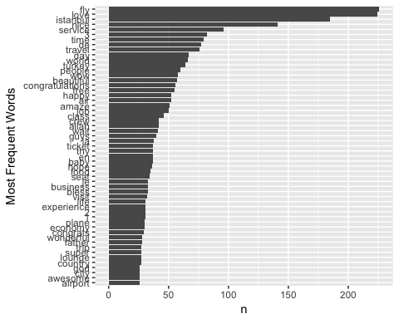

word_count_plot("TA_tokens_count_6846", 250)

## Joining, by = "word"

## Warning: Column `word` joining character vector and factor, coercing into  
## character vector

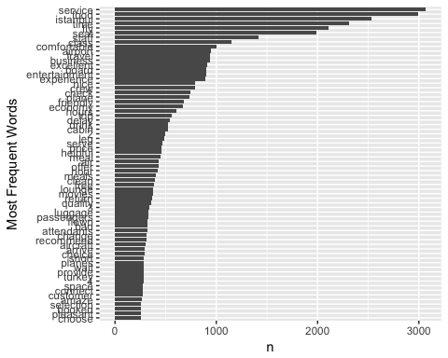

# Adding words manually to the lexicon  
sahban_irregular_lexicon <- readRDS("sahban_irregular_lexicon") %>%   
 bind_rows(data.frame(present = c("travel", "travel"),   
 irregular = c("travelled", "travelling")))  
saveRDS(sahban_irregular_lexicon, "sahban_irregular_lexicon")

# Indexed Response Function

numbered_response_tokens <- function(file, response_type) {  
   
 dataset <- readRDS(file = file)  
   
 dataset %>%   
 tibble::as_tibble() %>%   
 dplyr::mutate(response_type =   
 iconv(pull(., response_type),   
 from = "UTF-8", to = "Latin1")) %>%   
 dplyr::mutate(post_number = as.numeric(factor(id))) %>%   
 dplyr::group_by(id) %>%   
 dplyr::mutate_if(is.factor, as.character)  
}

# Convert irregular verbs into regular  
  
extract_irregular <- function(data) {  
 data %>%  
 dplyr::rename(irregular = word) %>%  
 dplyr::left_join(readRDS("sahban_irregular_lexicon"), by = "irregular") %>%  
 dplyr::mutate(present = ifelse(is.na(present), irregular, present)) %>%  
 dplyr::rename(word = present) %>%  
 dplyr::select(-one_of("irregular"))   
}

# Indexed Tokenization

The numbererd_response_function() is used to find out numbered tokenization.

tidy_response_facebook <-   
 numbered_response_tokens("300_posts_comments", "comments") %>%   
 dplyr::mutate(comment_number = row_number()) %>%   
 dplyr::select(id, post_number, response_number = comment_number,   
 comments, created_time, type, likes_count, comments_count,   
 shares_count) %>%   
 tidytext::unnest_tokens(word, comments) %>%   
 dplyr::anti_join(custom_stop_words) %>%   
 extract_irregular()

## Joining, by = "word"

## Warning: Column `word` joining character vector and factor, coercing into  
## character vector

tidy_response_tripadvisor <-   
 numbered_response_tokens("tripadvisor_turkishairlines6846.rds", "review") %>%   
 dplyr::select(id, response_number = post_number, review, quote, rating, date) %>%   
 tidytext::unnest_tokens(word, review) %>%   
 dplyr::anti_join(custom_stop_words) %>%   
 extract_irregular()

## Joining, by = "word"

## Warning: Column `word` joining character vector and factor, coercing into  
## character vector

tidy_response_facebook %>%   
 tibble::as_tibble() %>%   
 dplyr::select(post_number, response_number, word, type) %>%   
 subset(select = c(2,3,4,5))

## Adding missing grouping variables: `id`

## # A tibble: 24,016 x 4  
## post_number response_number word type   
## <dbl> <int> <chr> <chr>  
## 1 293 1 direct photo  
## 2 293 1 ireland photo  
## 3 293 1 bodrum photo  
## 4 293 1 badly photo  
## 5 293 1 week photo  
## 6 293 1 summer photo  
## 7 293 1 fantastic photo  
## 8 293 2 curious photo  
## 9 293 2 tbilisi photo  
## 10 293 3 fligths photo  
## # ... with 24,006 more rows

tidy_response_tripadvisor %>%   
 tibble::as_tibble() %>%   
 dplyr::select(id, response_number, word, quote)

## # A tibble: 124,188 x 4  
## # Groups: id [6,846]  
## id response_number word quote   
## <chr> <dbl> <chr> <chr>   
## 1 rn575914601 6846 start Never again..!!  
## 2 rn575914601 6846 sister Never again..!!  
## 3 rn575914601 6846 connection Never again..!!  
## 4 rn575914601 6846 istanbul Never again..!!  
## 5 rn575914601 6846 staff Never again..!!  
## 6 rn575914601 6846 sister Never again..!!  
## 7 rn575914601 6846 15 Never again..!!  
## 8 rn575914601 6846 minutes Never again..!!  
## 9 rn575914601 6846 explanation Never again..!!  
## 10 rn575914601 6846 talk Never again..!!  
## # ... with 124,178 more rows

# Sentence Tokenization

untidy_response_facebook <-   
 numbered_response_tokens("300_posts_comments", "comments") %>%   
 dplyr::mutate(comment_number = row_number()) %>%   
 dplyr::select(id, post_number, comment_number, comments,   
 created_time, type, likes_count, comments_count,   
 shares_count)  
  
untidy_response_tripadvisor <-   
 numbered_response_tokens("tripadvisor_turkishairlines6846.rds", "review") %>%   
 dplyr::select(id, post_number, review, quote, rating, date)  
  
  
sentence_tokens <- function(data = untidy_response_facebook,   
 response_column = "comments",   
 group_by = "comment_number") {  
 # English Dictionary  
 qdapDictionaries::DICTIONARY[,1]  
   
 en_word_comments <- data %>%   
 dplyr::ungroup() %>%   
 tidytext::unnest_tokens_("word", response_column) %>%   
 dplyr::filter(word %in% qdapDictionaries::DICTIONARY[,1])  
   
 en_word_sentence_comments <- en_word_comments %>%   
 dplyr::group_by_("id", group_by) %>%   
 dplyr::mutate(sentence = paste(word, collapse = " ")) %>%  
 dplyr::distinct(sentence, .keep_all = TRUE) %>%   
 dplyr::as_data_frame() %>%   
 dplyr::mutate(sentence = iconv(sentence, to = 'latin1')) %>%   
 dplyr::ungroup()  
   
 # Sentence as tokens with post number and comment number  
   
 en_word_sentence_comments %>%   
 dplyr::select_("id", group_by, "sentence") %>%  
 dplyr::ungroup() %>%   
 tidytext::unnest_tokens(sentences, sentence, token = "sentences")  
}  
  
facebook_sentence_tokens <-   
 sentence_tokens(data = untidy_response_facebook,  
 response_column = "comments",  
 group_by = "comment_number")  
  
tripadvisor_sentence_tokens <-   
 sentence_tokens(data = untidy_response_tripadvisor,  
 response_column = "review",  
 group_by = "post_number")  
  
facebook_sentence_tokens   
  
tripadvisor_sentence_tokens  
  
tripadvisor_sentence_tokens  
 dplyr::select(sentences)

# Response sentiments

response_sentiments <- function(data, lexicon, group_by = sentiment) {  
 data %>%   
 dplyr::inner_join(get_sentiments(lexicon), by = "word") %>%   
 dplyr::count(response_number, sentiment) %>%   
 tidyr::spread(sentiment, n, fill = 0) %>%   
 dplyr::mutate(sentiment = positive - negative) %>%   
 dplyr::ungroup()  
}  
  
# bing  
facebook_sentiments_bing <- response_sentiments(tidy_response_facebook, "bing")  
tripadvisor_sentiments_bing <- response_sentiments(tidy_response_tripadvisor, "bing")  
  
# nrc  
facebook_sentiments_nrc <- response_sentiments(tidy_response_facebook, "nrc")  
tripadvisor_sentiments_nrc <- response_sentiments(tidy_response_tripadvisor, "nrc")  
  
#afinn  
sentiments_afinn <- function(data) {  
 data %>%   
 dplyr::ungroup() %>%   
 dplyr::inner_join(tidytext::get_sentiments("afinn"), by = "word") %>%   
 dplyr::group_by(id, response_number) %>%   
 dplyr::summarise(score = sum(score))   
}  
  
facebook_sentiments_afinn <- sentiments_afinn(tidy_response_facebook)  
tripadvisor_sentiments_afinn <- sentiments_afinn(tidy_response_tripadvisor)  
  
facebook_sentiments_bing %>%   
 dplyr::select(response_number, negative, positive, sentiment)

## # A tibble: 1,586 x 4  
## response_number negative positive sentiment  
## <int> <dbl> <dbl> <dbl>  
## 1 1 0 1 1  
## 2 2 0 1 1  
## 3 3 0 1 1  
## 4 3 1 0 -1  
## 5 4 0 1 1  
## 6 2 0 1 1  
## 7 3 3 1 -2  
## 8 18 0 1 1  
## 9 21 0 2 2  
## 10 23 0 1 1  
## # ... with 1,576 more rows

tripadvisor_sentiments_bing

## # A tibble: 6,423 x 5  
## id response_number negative positive sentiment  
## <chr> <dbl> <dbl> <dbl> <dbl>  
## 1 rn342674723 1 1 0 -1  
## 2 rn342740773 2 1 3 2  
## 3 rn342772345 3 4 1 -3  
## 4 rn342937701 4 0 3 3  
## 5 rn343011985 5 1 1 0  
## 6 rn343117108 6 0 1 1  
## 7 rn343117743 7 0 2 2  
## 8 rn343141565 8 4 2 -2  
## 9 rn343168849 9 0 4 4  
## 10 rn343189478 10 0 3 3  
## # ... with 6,413 more rows

facebook_sentiments_nrc

## # A tibble: 1,867 x 13  
## id response_number anger anticipation disgust fear joy negative  
## <chr> <int> <dbl> <dbl> <dbl> <dbl> <dbl> <dbl>  
## 1 904300… 1 0 0 0 0 2 0  
## 2 904300… 2 0 0 0 0 1 0  
## 3 904300… 3 0 0 0 0 1 0  
## 4 904300… 4 0 0 0 0 0 0  
## 5 904300… 1 0 1 0 0 0 1  
## 6 904300… 4 0 0 0 0 0 0  
## 7 904300… 2 1 2 0 1 1 0  
## 8 904300… 3 0 0 0 0 0 3  
## 9 904300… 4 0 0 0 1 0 0  
## 10 904300… 5 0 1 0 0 0 0  
## # ... with 1,857 more rows, and 5 more variables: positive <dbl>,  
## # sadness <dbl>, surprise <dbl>, trust <dbl>, sentiment <dbl>

tripadvisor_sentiments_nrc

## # A tibble: 6,788 x 13  
## id response_number anger anticipation disgust fear joy negative  
## <chr> <dbl> <dbl> <dbl> <dbl> <dbl> <dbl> <dbl>  
## 1 rn3426… 1 0 2 0 0 0 2  
## 2 rn3427… 2 1 2 1 2 3 0  
## 3 rn3427… 3 2 0 2 1 0 3  
## 4 rn3429… 4 0 2 0 0 3 0  
## 5 rn3430… 5 1 2 1 1 1 1  
## 6 rn3431… 6 0 2 0 0 1 0  
## 7 rn3431… 7 0 3 0 0 4 0  
## 8 rn3431… 8 1 1 1 2 2 4  
## 9 rn3431… 9 0 3 0 0 3 0  
## 10 rn3431… 10 1 2 0 1 2 0  
## # ... with 6,778 more rows, and 5 more variables: positive <dbl>,  
## # sadness <dbl>, surprise <dbl>, trust <dbl>, sentiment <dbl>

facebook_sentiments_afinn

## # A tibble: 1,645 x 3  
## # Groups: id [?]  
## id response_number score  
## <chr> <int> <int>  
## 1 90430042759_10155125620582760 1 5  
## 2 90430042759_10155125620582760 2 3  
## 3 90430042759_10155125620582760 3 3  
## 4 90430042759_10155125620582760 7 2  
## 5 90430042759_10155126945012760 3 2  
## 6 90430042759_10155126945012760 4 2  
## 7 90430042759_10155129495572760 2 3  
## 8 90430042759_10155129495572760 3 -3  
## 9 90430042759_10155129495572760 11 -1  
## 10 90430042759_10155129495572760 18 1  
## # ... with 1,635 more rows

tripadvisor_sentiments_afinn

## # A tibble: 6,131 x 3  
## # Groups: id [?]  
## id response_number score  
## <chr> <dbl> <int>  
## 1 rn342674723 1 0  
## 2 rn342740773 2 7  
## 3 rn342772345 3 -2  
## 4 rn342937701 4 5  
## 5 rn343011985 5 -3  
## 6 rn343117108 6 2  
## 7 rn343117743 7 5  
## 8 rn343141565 8 -5  
## 9 rn343168849 9 6  
## 10 rn343189478 10 7  
## # ... with 6,121 more rows

# Sentiments to All Words Ratio

sentiment_token_ratio <- function(data, sentiment_type = "negative") {  
   
 negative_sentiment <- get_sentiments("bing") %>%   
 dplyr::filter(sentiment == sentiment_type)  
   
 wordcounts <- data %>%   
 dplyr::group_by(response_number) %>%  
 dplyr::summarize(word = n())  
   
 data %>%  
 dplyr::semi_join(negative_sentiment) %>%  
 dplyr::group_by(id, response_number) %>%  
 dplyr::summarize(negativewords = n()) %>%  
 dplyr::left_join(wordcounts, by = c("response_number")) %>%  
 dplyr::mutate(ratio = negativewords/word) %>%  
 dplyr::top_n(10) %>%  
 dplyr::ungroup() %>%   
 dplyr::arrange(desc(ratio))  
   
}  
  
facebook_negative_sentiment_ratio <-   
 sentiment_token_ratio(tidy_response_facebook, "negative")

## Joining, by = "word"

## Selecting by ratio

tripadvisor_negative_sentiment_ratio <-   
 sentiment_token_ratio(tidy_response_tripadvisor, "negative")

## Joining, by = "word"  
## Selecting by ratio

facebook_positive_sentiment_ratio <-   
 sentiment_token_ratio(tidy_response_facebook, "positive")

## Joining, by = "word"  
## Selecting by ratio

tripadvisor_positive_sentiment_ratio <-   
 sentiment_token_ratio(tidy_response_tripadvisor, "positive")

## Joining, by = "word"  
## Selecting by ratio

facebook_negative_sentiment_ratio

## # A tibble: 192 x 5  
## id response_number negativewords word ratio  
## <chr> <int> <int> <int> <dbl>  
## 1 90430042759_101551815520227… 281 1 2 0.5   
## 2 90430042759_101551815520227… 805 1 2 0.5   
## 3 90430042759_101551815520227… 661 1 3 0.333   
## 4 90430042759_101551815520227… 687 1 3 0.333   
## 5 90430042759_101551815520227… 503 2 11 0.182   
## 6 90430042759_101551815520227… 358 1 6 0.167   
## 7 90430042759_101551815520227… 314 1 7 0.143   
## 8 90430042759_101551815520227… 157 1 8 0.125   
## 9 90430042759_101551815520227… 475 1 10 0.1   
## 10 90430042759_101551815520227… 69 2 30 0.0667  
## # ... with 182 more rows

tripadvisor_negative_sentiment_ratio

## # A tibble: 3,384 x 5  
## id response_number negativewords word ratio  
## <chr> <dbl> <int> <int> <dbl>  
## 1 rn541387435 4976 5 7 0.714  
## 2 rn465760178 3008 4 8 0.5   
## 3 rn525881971 4705 4 8 0.5   
## 4 rn518927507 4384 5 11 0.455  
## 5 rn513737468 3993 4 9 0.444  
## 6 rn425622278 2284 9 21 0.429  
## 7 rn557983424 5965 3 7 0.429  
## 8 rn569818446 6477 3 7 0.429  
## 9 rn530267095 4794 4 10 0.4   
## 10 rn547414313 5547 4 10 0.4   
## # ... with 3,374 more rows

numbered_response_tokens(  
 "tripadvisor_turkishairlines6846.rds", "review") %>%   
 dplyr::select(id, response_number = post_number, review,   
 quote, rating, date) %>%   
 dplyr::filter(response_number == 4976) %>%   
 dplyr::select(review, id)

## # A tibble: 1 x 2  
## # Groups: id [1]  
## review id   
## <chr> <chr>   
## 1 "\nthe flight was very bad and the food very bad it so bad and … rn5413…

# Most Frequent Sentiments

frequent_sentiments <- function(data) {  
 data %>%   
 dplyr::inner_join(tidytext::get_sentiments("bing")) %>%   
 dplyr::ungroup() %>%   
 dplyr::count(word, sentiment, sort = TRUE)  
}  
  
facebook_frequent_sentiments <- frequent_sentiments(tidy_response_facebook)

## Joining, by = "word"

tripadvisor_frequent_sentiments <- frequent_sentiments(tidy_response_tripadvisor)

## Joining, by = "word"

facebook_frequent_sentiments

## # A tibble: 384 x 3  
## word sentiment n  
## <chr> <chr> <int>  
## 1 love positive 328  
## 2 nice positive 155  
## 3 beautiful positive 87  
## 4 congratulations positive 83  
## 5 wow positive 80  
## 6 amaze positive 73  
## 7 free positive 72  
## 8 happy positive 69  
## 9 bless positive 45  
## 10 super positive 37  
## # ... with 374 more rows

tripadvisor_frequent_sentiments

## # A tibble: 1,317 x 3  
## word sentiment n  
## <chr> <chr> <int>  
## 1 comfortable positive 1026  
## 2 excellent positive 927  
## 3 nice positive 816  
## 4 friendly positive 700  
## 5 delay negative 552  
## 6 helpful positive 472  
## 7 clean positive 406  
## 8 free positive 399  
## 9 bad negative 324  
## 10 recommend positive 318  
## # ... with 1,307 more rows

# Plot Frequent Sentiments Counts

plot_sentiment_count <- function(data) {  
 data %>%   
 dplyr::group_by(sentiment) %>%   
 dplyr::top_n(10) %>%   
 dplyr::ungroup() %>%   
 dplyr::mutate(word = reorder(word, n)) %>%   
 ggplot2::ggplot(ggplot2::aes(word, n, fill = sentiment)) +  
 ggplot2::geom_col(show.legend = FALSE) +  
 ggplot2::facet_wrap(~sentiment, scales = "free_y") +  
 ggplot2::labs(y = "Frequent Sentiments",  
 x = "Frequency") +  
 ggplot2::coord_flip()  
}  
  
plot_sentiment_count(facebook_frequent_sentiments)

## Selecting by n

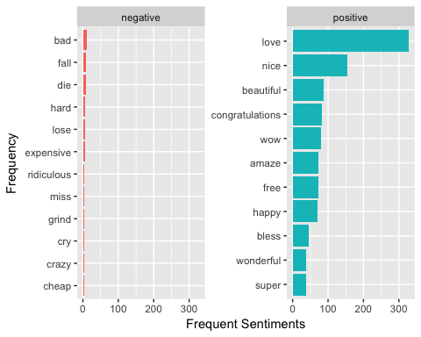

plot_sentiment_count(tripadvisor_frequent_sentiments)

## Selecting by n

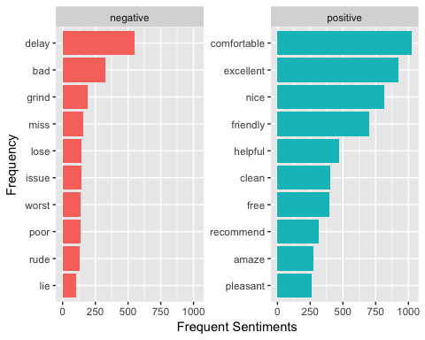

# Word Cloud

library(wordcloud)

## Loading required package: RColorBrewer

word_cloud <- function(data, max_words) {  
 data %>%  
 dplyr::ungroup() %>%   
 dplyr::count(word) %>%  
 with(wordcloud::wordcloud(word, n, max.words = max_words))  
}  
  
word_cloud(tidy_response_facebook, max_words = 50)

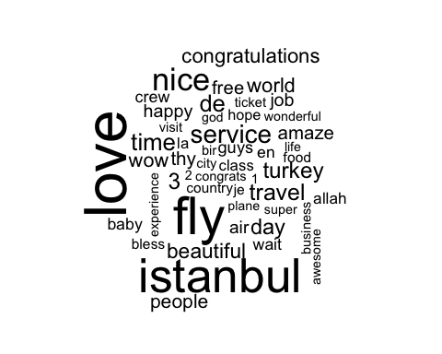

word_cloud(tidy_response_tripadvisor, max_words = 75)

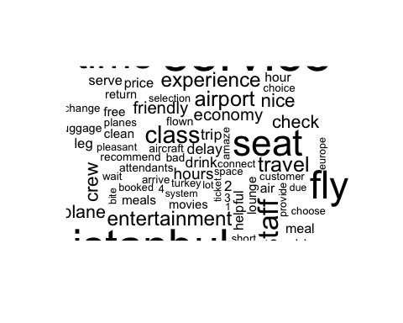

# Sentiment Cloud

library(reshape2)  
  
sentiment_cloud <- function(dataset) {  
 dataset %>%  
 dplyr::inner_join(tidytext::get_sentiments("bing")) %>%  
 dplyr::count(word, sentiment, sort = TRUE) %>%  
 reshape2::acast(word ~ sentiment, value.var = "n", fill = 0) %>%  
 wordcloud::comparison.cloud(colors = c("#F8766D", "#00BFC4"),  
 max.words = 100)  
}  
  
sentiment_cloud(tidy_response_facebook)

## Joining, by = "word"

## Aggregation function missing: defaulting to length

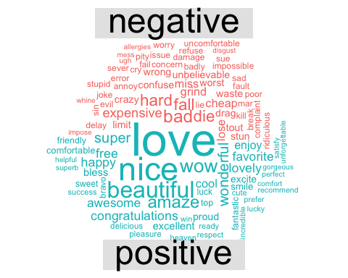

sentiment_cloud(tidy_response_tripadvisor)

## Joining, by = "word"  
## Aggregation function missing: defaulting to length

## Warning in wordcloud::comparison.cloud(., colors = c("#F8766D",  
## "#00BFC4"), : friendly could not be fit on page. It will not be plotted.

## Warning in wordcloud::comparison.cloud(., colors = c("#F8766D",  
## "#00BFC4"), : recommend could not be fit on page. It will not be plotted.

## Warning in wordcloud::comparison.cloud(., colors = c("#F8766D",  
## "#00BFC4"), : delicious could not be fit on page. It will not be plotted.

## Warning in wordcloud::comparison.cloud(., colors = c("#F8766D",  
## "#00BFC4"), : impress could not be fit on page. It will not be plotted.

## Warning in wordcloud::comparison.cloud(., colors = c("#F8766D",  
## "#00BFC4"), : decent could not be fit on page. It will not be plotted.

## Warning in wordcloud::comparison.cloud(., colors = c("#F8766D",  
## "#00BFC4"), : pretty could not be fit on page. It will not be plotted.

## Warning in wordcloud::comparison.cloud(., colors = c("#F8766D",  
## "#00BFC4"), : wonderful could not be fit on page. It will not be plotted.

## Warning in wordcloud::comparison.cloud(., colors = c("#F8766D",  
## "#00BFC4"), : fantastic could not be fit on page. It will not be plotted.

## Warning in wordcloud::comparison.cloud(., colors = c("#F8766D",  
## "#00BFC4"), : variety could not be fit on page. It will not be plotted.

## Warning in wordcloud::comparison.cloud(., colors = c("#F8766D",  
## "#00BFC4"), : courteous could not be fit on page. It will not be plotted.

## Warning in wordcloud::comparison.cloud(., colors = c("#F8766D",  
## "#00BFC4"), : happy could not be fit on page. It will not be plotted.

## Warning in wordcloud::comparison.cloud(., colors = c("#F8766D",  
## "#00BFC4"), : reasonable could not be fit on page. It will not be plotted.

## Warning in wordcloud::comparison.cloud(., colors = c("#F8766D",  
## "#00BFC4"), : super could not be fit on page. It will not be plotted.

## Warning in wordcloud::comparison.cloud(., colors = c("#F8766D",  
## "#00BFC4"), : spacious could not be fit on page. It will not be plotted.

## Warning in wordcloud::comparison.cloud(., colors = c("#F8766D",  
## "#00BFC4"), : warm could not be fit on page. It will not be plotted.

## Warning in wordcloud::comparison.cloud(., colors = c("#F8766D",  
## "#00BFC4"), : outstanding could not be fit on page. It will not be plotted.

## Warning in wordcloud::comparison.cloud(., colors = c("#F8766D",  
## "#00BFC4"), : pleasantly could not be fit on page. It will not be plotted.

## Warning in wordcloud::comparison.cloud(., colors = c("#F8766D",  
## "#00BFC4"), : prefer could not be fit on page. It will not be plotted.

## Warning in wordcloud::comparison.cloud(., colors = c("#F8766D",  
## "#00BFC4"), : lovely could not be fit on page. It will not be plotted.

## Warning in wordcloud::comparison.cloud(., colors = c("#F8766D",  
## "#00BFC4"), : satisfy could not be fit on page. It will not be plotted.

## Warning in wordcloud::comparison.cloud(., colors = c("#F8766D",  
## "#00BFC4"), : superb could not be fit on page. It will not be plotted.

## Warning in wordcloud::comparison.cloud(., colors = c("#F8766D",  
## "#00BFC4"), : enjoyable could not be fit on page. It will not be plotted.

## Warning in wordcloud::comparison.cloud(., colors = c("#F8766D",  
## "#00BFC4"), : comfy could not be fit on page. It will not be plotted.

## Warning in wordcloud::comparison.cloud(., colors = c("#F8766D",  
## "#00BFC4"), : convenient could not be fit on page. It will not be plotted.

## Warning in wordcloud::comparison.cloud(., colors = c("#F8766D",  
## "#00BFC4"), : pleasure could not be fit on page. It will not be plotted.

## Warning in wordcloud::comparison.cloud(., colors = c("#F8766D",  
## "#00BFC4"), : awesome could not be fit on page. It will not be plotted.

## Warning in wordcloud::comparison.cloud(., colors = c("#F8766D",  
## "#00BFC4"), : improve could not be fit on page. It will not be plotted.

## Warning in wordcloud::comparison.cloud(., colors = c("#F8766D",  
## "#00BFC4"), : welcome could not be fit on page. It will not be plotted.

